How to convert \*.ppk file to use with SSH.NET library

1. Run Putty Key Generator from ThirdParty directory located in Core project
2. Open \*.ppk file used for WinSCP

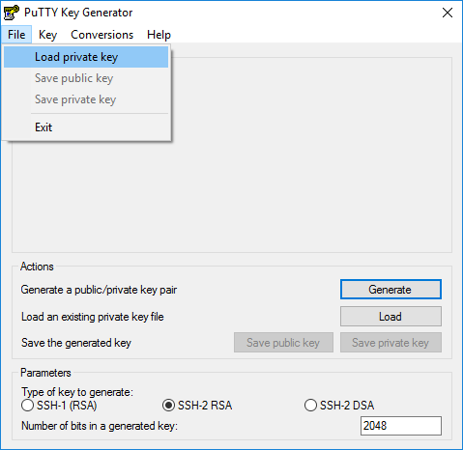

The private key file should begin with BEGIN RSA PRIVATE KEY.

1. Go to the Conversions menu and choose Export OpenSSH Key.

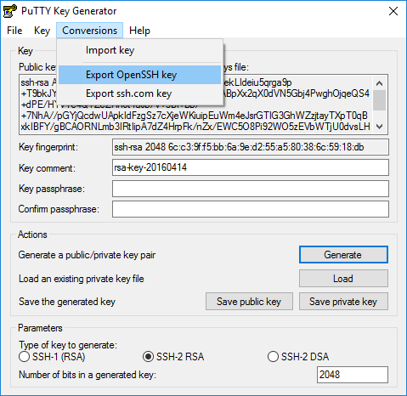

The private key file should begin with BEGIN RSA PRIVATE KEY.

1. Save that new key to a file and use it.